April 29, 2014

Karyn Vandervoort

Federal Highway Administration

**228 Walnut Street, Room 508  
Harrisburg, PA 17101-1720**

Re: PSU/DGS Master Agreement

Work Order 10

SPR Funding Approval

Dear Mrs. Vandervoort:

Attached for your review and approval is the draft scope of work and draft budget for Work Order 10, “Best Practices for the Design, Evaluation and Quality Control of High Percentage RAP Mixes”, under the Department of General Services & Penn State University Master Agreement.

We are requesting State Planning and Research funding approval for $55,694.00 to support this twelve (12) month project.

If you have any questions please feel free to call me. Thank you for your time and review of this worthwhile research request.

Sincerely,

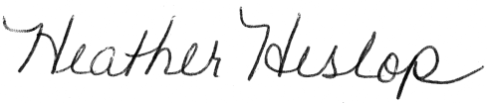

Heather Heslop

Contract Administrator

Bureau of Planning and Research